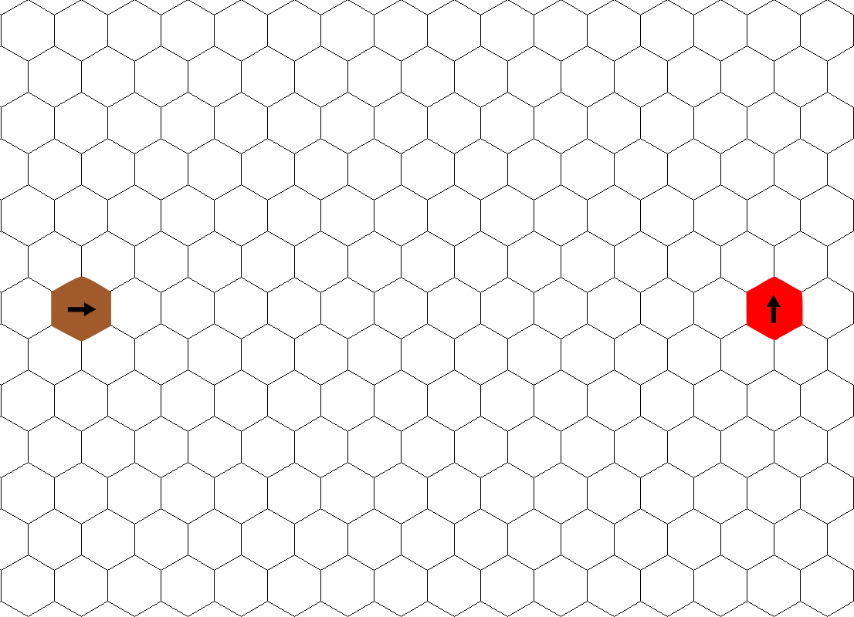

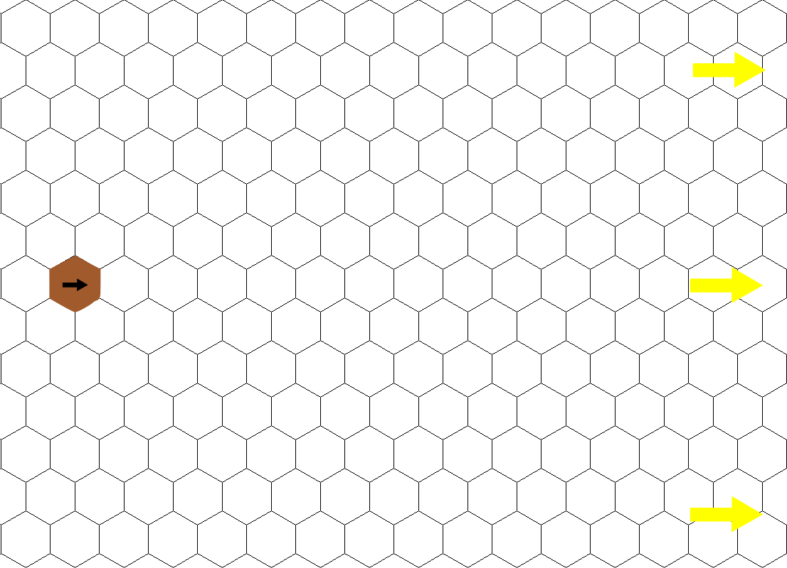Level 1-1

Level 1-2

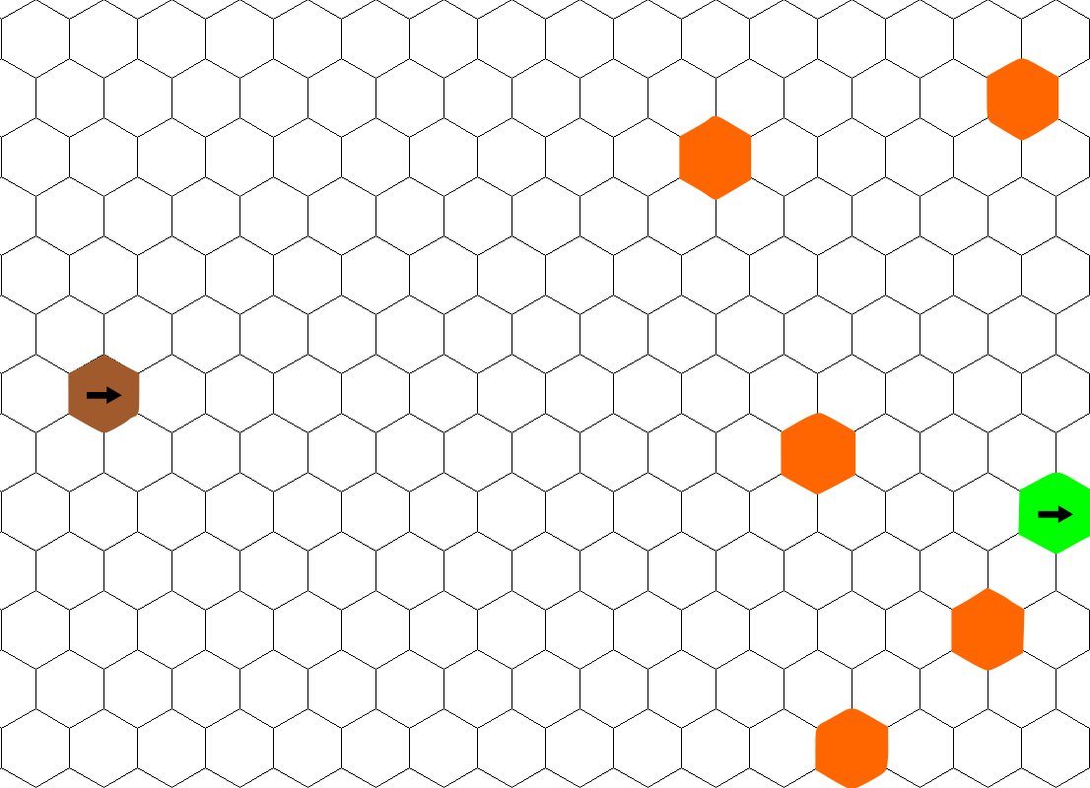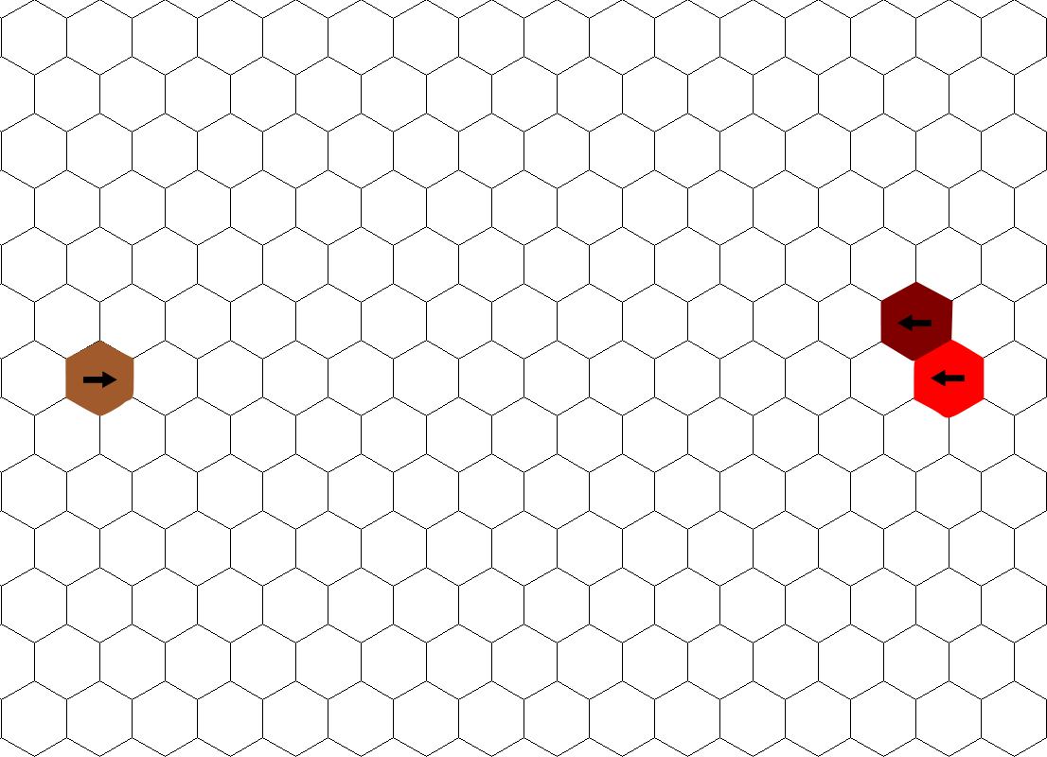

Level 2-1

Level 1-3

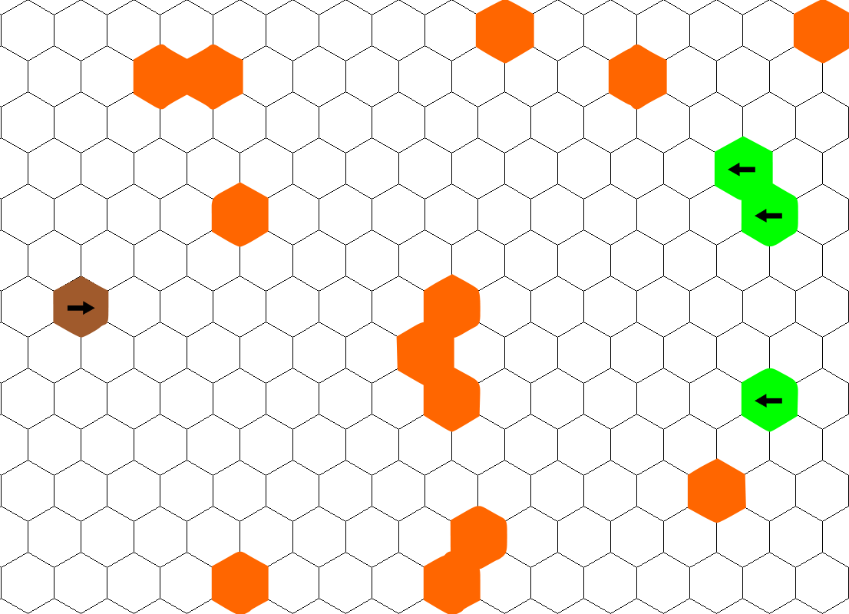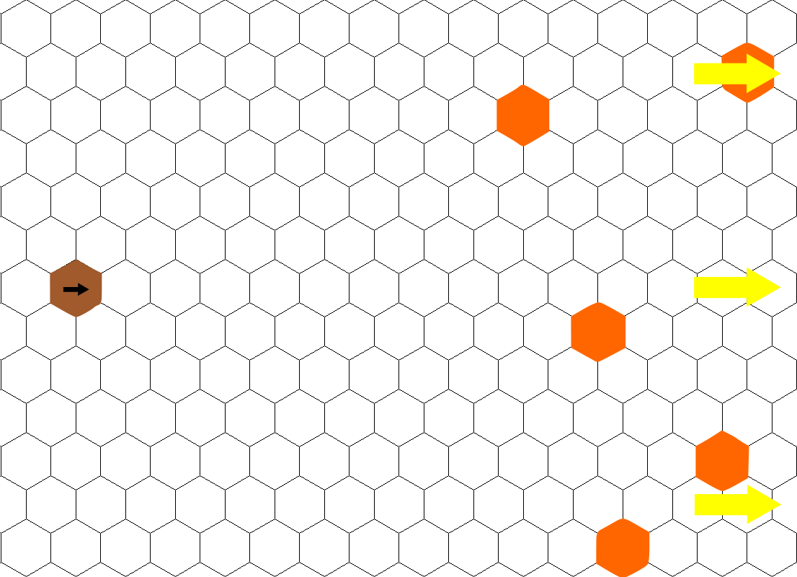

Level 2-3

Level 2-2

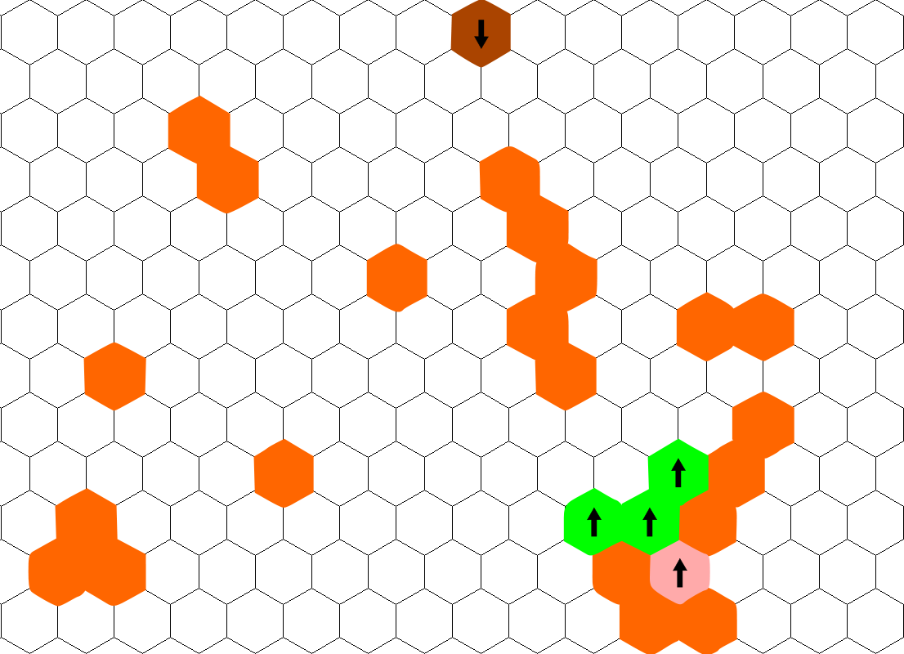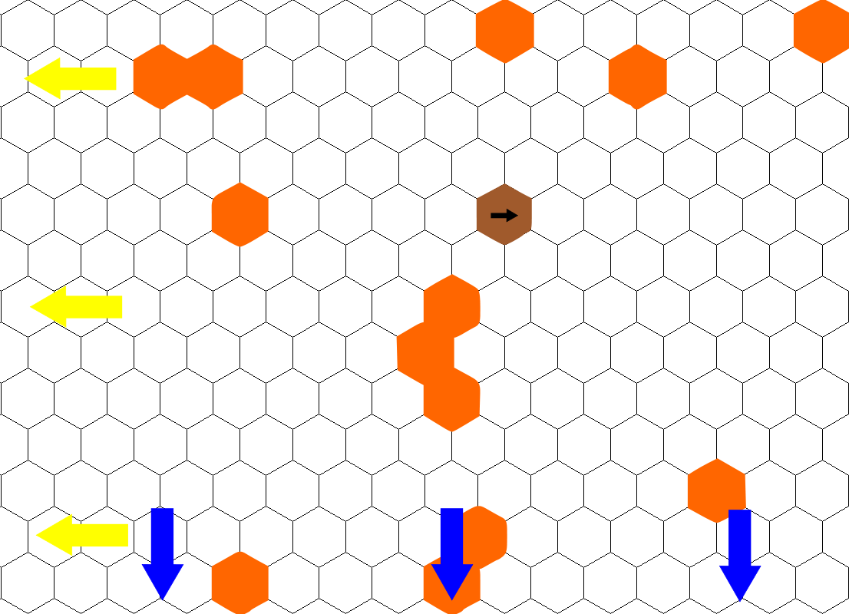

Level 2-5 (Optional)

Level 2-4

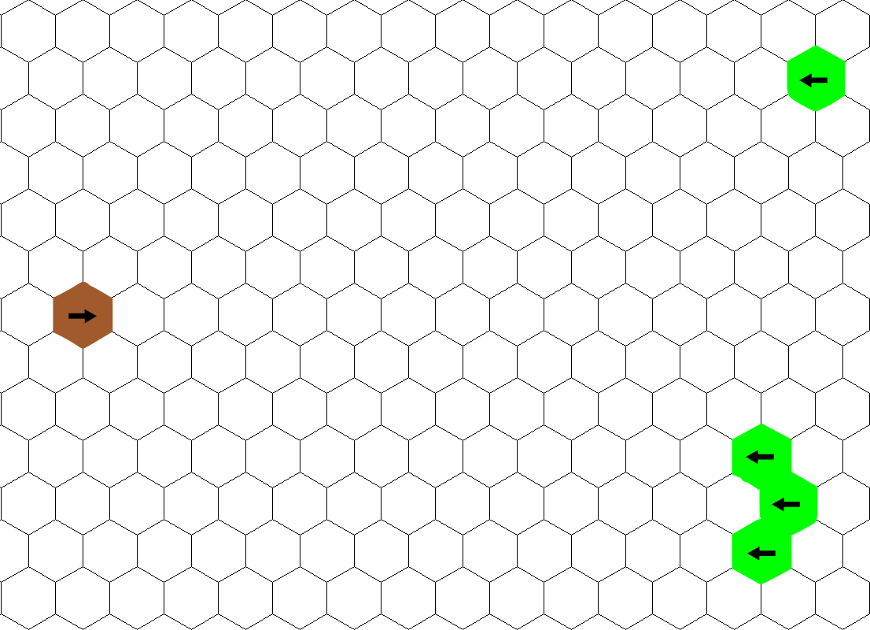

Level 3-2

Level 3-1

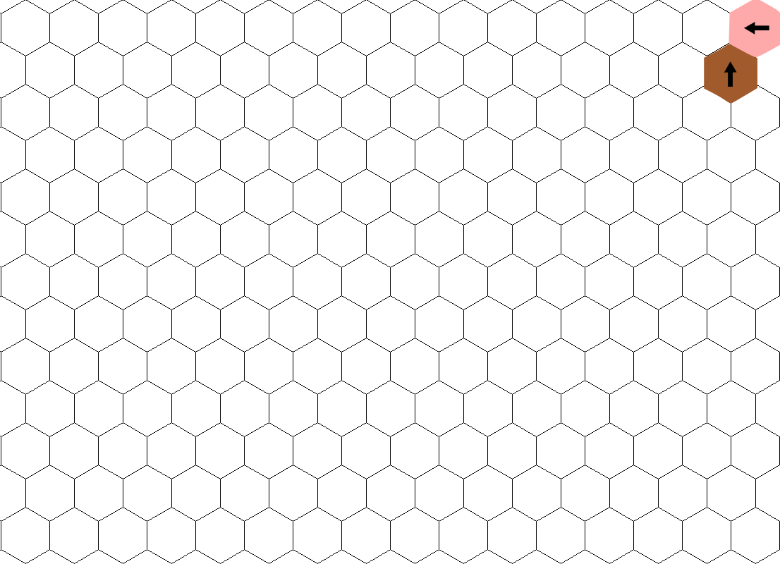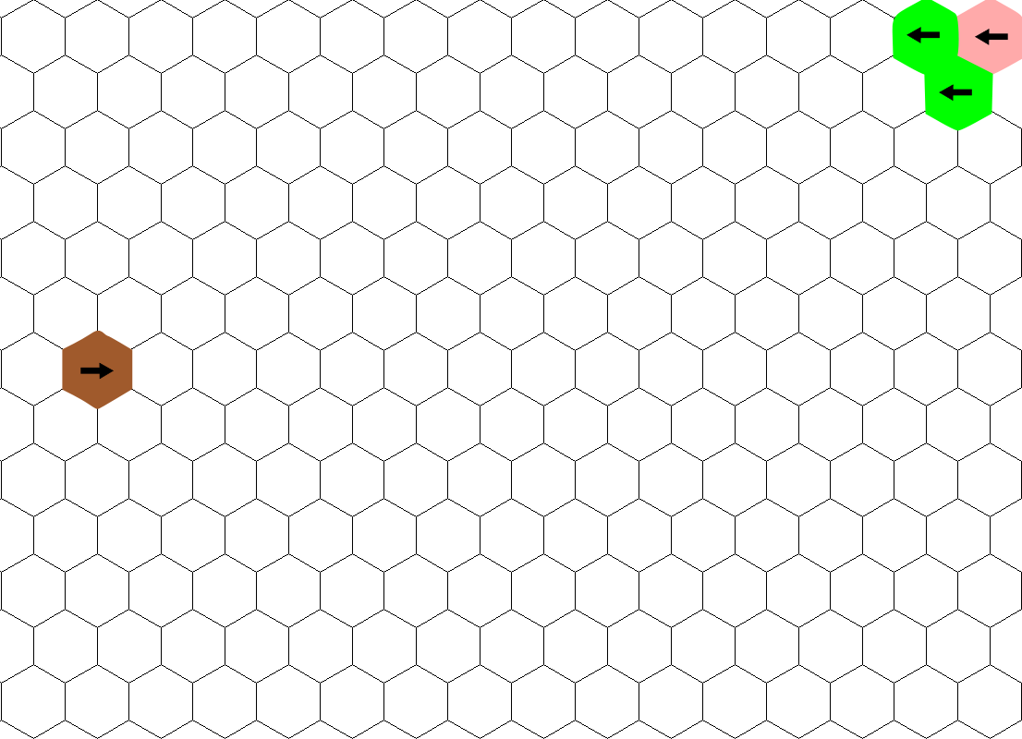

Level 3-4

Level 3-3

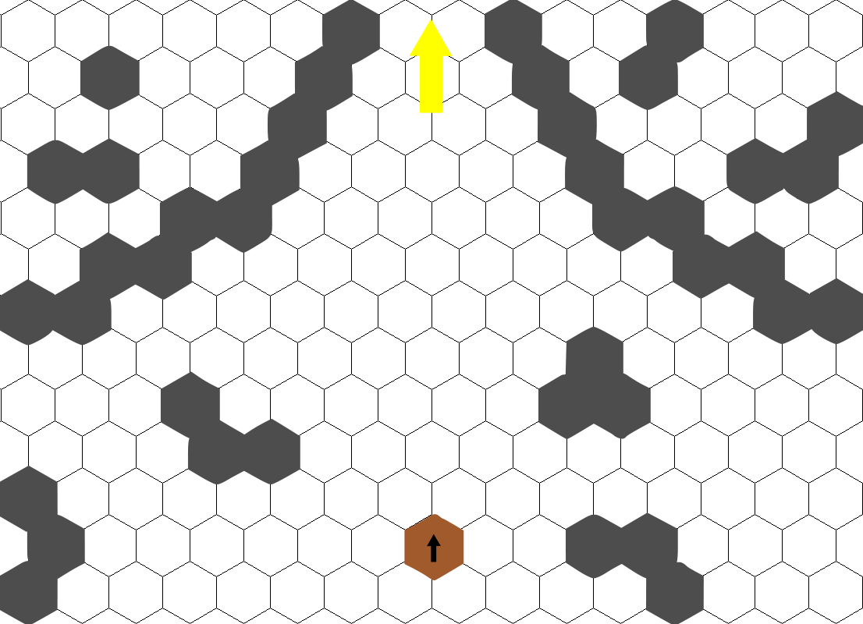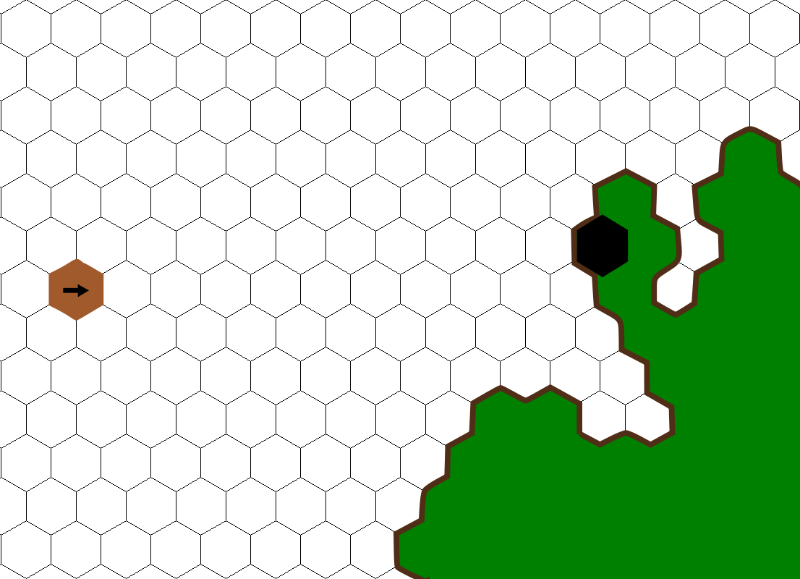

Level 4-2

Level 4-1

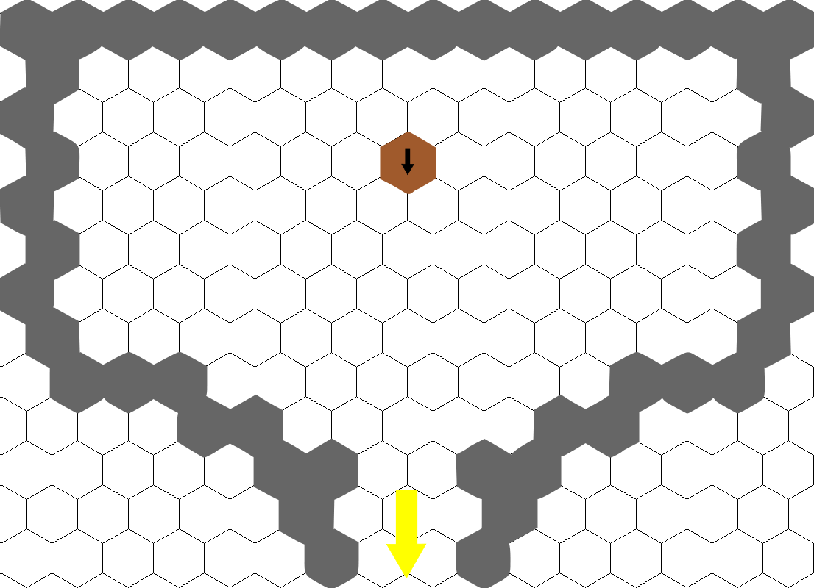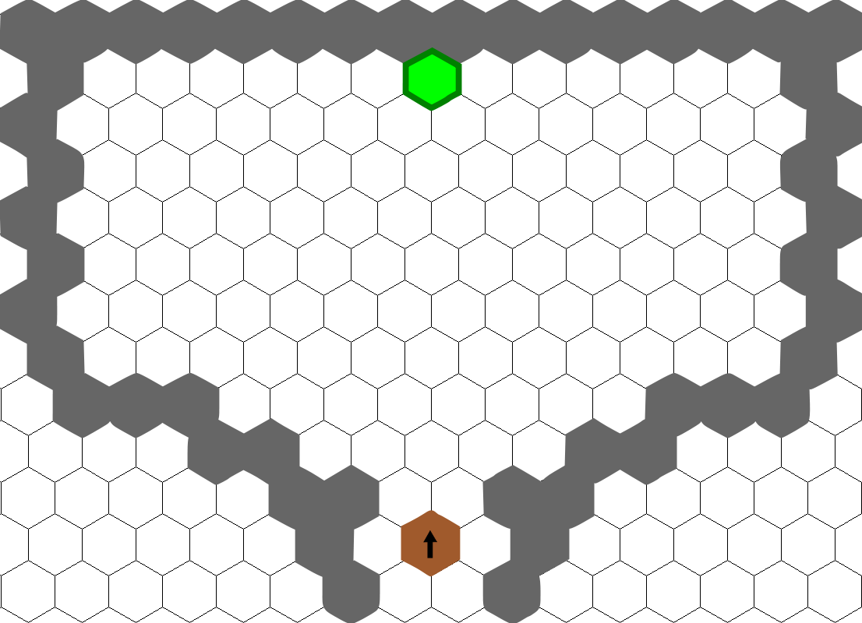

Level 4-4

Level 4-3

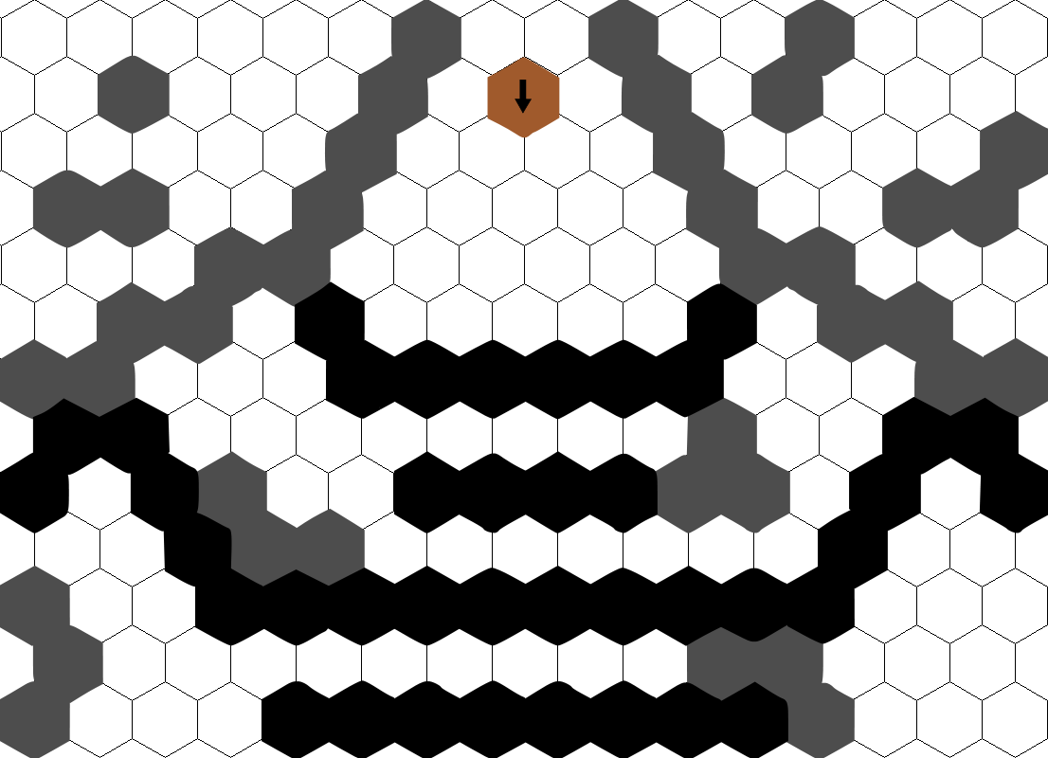

Level 4-5

**Legend:**

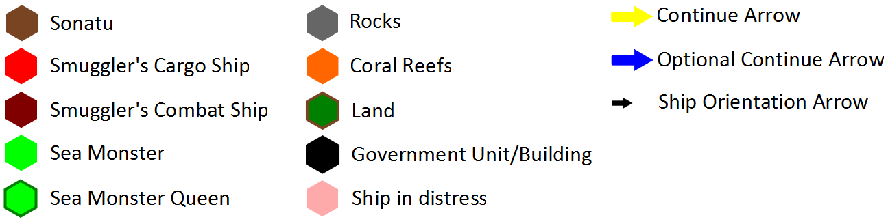

**Level Map Descriptions:**

**Level 1-1**  
Unit on right is smuggler’s cargo ship. After the player ends their first turn, the cargo ship exits the screen on the right.  
  
**Level 1-2**  
The player must exit at the right side of the screen.  
  
**Level 1-3**  
The two units on the right are the cargo ship and its escort. The cargo ship stays at the back, while its escort engages the player. When the escort is defeated, the mission ends.  
  
**Level 2-1**  
The sea monster on the right of the screen leaves soon after the map is shown.  
  
**Level 2-2**  
When the player is given control, they must exit the screen at the right side.  
  
**Level 2-3**  
All enemy units behave normally. The player must defeat all of them to move on.  
  
**Level 2-4**  
After the defeat of the monsters, the player is given a choice. Exiting at the left side returns the player to port to start the next mission. Exiting at the bottom side extends the mission and allows the player to gain a special attack.  
  
**Level 2-5 (optional)**  
The ship at the bottom of the screen makes no moves, and is for all purposes an obstacle. The sea monsters attack normally, and the player must defeat all of them. Afterward, the player receives a special attack (grape shot).  
  
**Level 3-1**  
The player enters from the left side of the screen; four sea monsters are on the right side of the screen and move to attack the player when they enter.  The player must defeat these sea monsters to continue.  
  
**Level 3-2**  
Once the sea monsters are defeated, arrows appear to prompt the player to exit via the right side of the screen.  
  
**Level 3-3**  
The player enters from the left side of the screen; two sea monsters are in the upper right corner, alongside a ship in distress. The ship is on fire, and will be completely consumed after a certain number of turns. If this occurs, it’s game over. The player must defeat the sea monsters to continue.

**Level 3-4**  
The player must speak with the distressed ship to finish the mission.  
  
**Level 4-1**  
The player enters from the left of the screen; land dominates the right-bottom corner of the map; a land based military base is on the land almost directly across from the player.  The player must speak with the military base to continue.  
  
**Level 4-2**  
After speaking with the military base from level, arrows appear indicating the player must exit via the top of the map.  
  
**Level 4-3**  
**Fade out - Fade in**   
The player appears at the south of the next map. The far end of the map is shaped to funnel them into the center gap. They must exit via the top of the map, as indicated by an arrow. The obstacles are rocks.  
  
**Level 4-4**  
The player enters from the south and is faced with an enclosed cavern.  The Queen awaits at the far wall and will move to attack when the player enters.  The player must destroy the Queen to proceed.  
  
**Level 4-5**  
Once the player has defeated the Queen, arrows appear indicating that they must exit through the bottom of the screen to continue.  
  
**Level 4-6**  
Upon exiting the Queen’s lair, the player enters this screen from the top.  Lines of military ships are arrayed outside the lair, oriented on the player.  The player is expected to perish, but is allowed to move and fire as if in normal combat until they die.  This is the final mission and the ending cutscene will play once the player is dead.